

SQL PROJECT ON OPD APPOINTMENTS

BY

AMOL DHALE

Contents

1. INTRODUCTION 3

2. ER DIAGRAM 4

3. DATA DEFINATION LANGUAGE (DDL) 5

4. DATA MANIPULATION LANGUAGE (DML) 10

5. DATA QUERY LANGUAGE (DQL) 11

1. INTRODUCTION

In the dynamic and critical domain of healthcare, efficient management of data plays a pivotal role in ensuring the delivery of high-quality patient care. The adoption of robust information systems is crucial for hospitals to streamline their operations, enhance decision-making processes, and ultimately improve patient outcomes. This SQL project aims to address the specific needs of a hospital environment, providing a comprehensive and organized database solution.

In this SQL project I am going to guide you through the most important process which is OPD appointments. Front office of any hospital is responsible to carry out many activities. They have to handle hospital reception where major tasks like handling customer enquiries, guiding patient relatives during visiting hours, dispatching health reports on the counter, providing OPD appointments or guiding them to OPD department for appointments, Handling EPABX system and providing accurate and related information to the caller and many more.

They are 2 main departments in the Hospital the first one is an OPD (OUT PATIENT DEPARTMENT) and second is IPD (IN PATIENT DEPARTMENT).

This SQL project is focussing more on the outpatient department and a process called OPD appointments. Basic process followed here is below.

Please note here the process of data collection happens during the initial stage i.e. when the customer calls customer care or visit hospitals reception/OPD area.

Customer has to fill a registration form and give relevant details. In case a customer is already registered than details are available in the system. So no need of registering the customer again. If he is visiting for the first time consider it as consultation and if he is making a follow within a month times or as per hospital rules then follow-up charges will apply.

Now let’s proceed towards customer registration and database creation in MySQL.

1. ER DIAGRAM

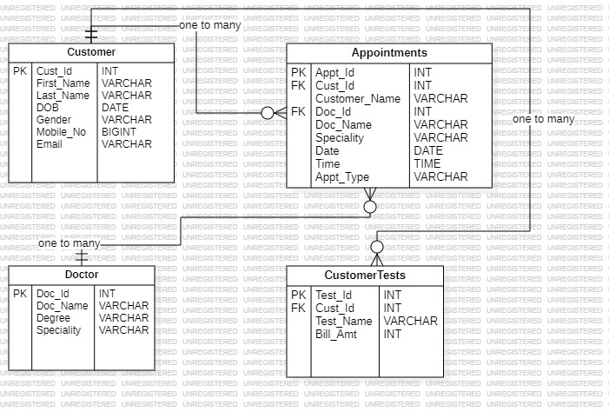

1. DATA DEFINATION LANGUAGE (DDL)

**DATABASE DESIGN (SCHEMA)**

|  |  |
| --- | --- |
| **DATABASE NAME** | **HOSPITAL** |
| **TABLE NAME** | **CUSTOMER** |
| **DOCTOR** |
| **TESTS** |
| **APPOINTMENTS** |

**CREATE DATABASE Hospital;**



**USE DATABASE Hospital;**



**CREATE TABLE Customer;**

|  |  |
| --- | --- |
| **Cust_id** | **INT PRIMARY KEY** |
| **First_Name** | **VARCHAR(50)** |
| **Last_Name** | **VARCHAR(50)** |
| **DOB** | **DATE** |
| **Gender** | **VARCHAR(10)** |
| **Mobile_No** | **BIGINT** |
| **Email** | **VARCHAR(100)** |

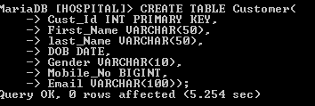

**DESCRIBE STRUCTURE OF TABLE CUSTOMER.**

**DESC Customer;**

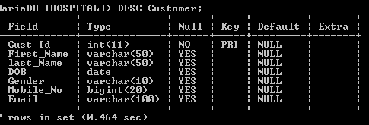

**CREATE TABLE Doctor;**

|  |  |
| --- | --- |
| **Doc_Id** | **INT PRIMARY KEY** |
| **Doc_Name** | **VARCHAR(50)** |
| **Degree** | **VARCHAR(50)** |
| **Speciality** | **VARCHAR(20)** |

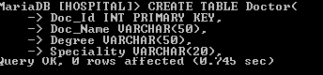

**DESCRIBE STRUCTURE OF TABLE DOCTOR.**

**DESC Doctor;**

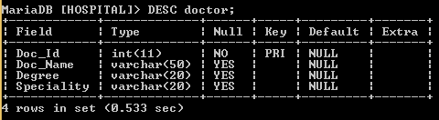

**CREATE TABLE CustomerTests;**

|  |  |
| --- | --- |
| **Cust_Id** | **INT FOREIGN KEY (Cust_Id) REFERENCES Customer(Cust_Id)** |
| **Test_Id** | **INT PRIMARY KEY** |
| **Test_Name** | **VARCHAR(50)** |
| **Bill_Amt** | **INT** |

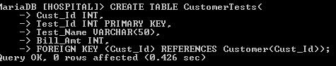

**DESCRIBE STRUCTURE OF TABLE TESTS.**

**DESC Tests;**

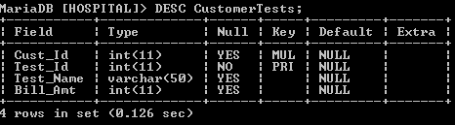

**CREATE TABLE Appointments;**

|  |  |
| --- | --- |
| **Appt_Id** | **INT PRIMARY KEY** |
| **Cust_Id** | **INT FOREIGN KEY(Cust_Id) REFERENCES customer(Cust_Id);** |
| **Customer_Name** | **VARCHAR(50)** |
| **Doc_Id** | **INT FOREIGN KEY(Doc_Id) REFERENCES doctor(Doc_Id)** |
| **Doctor_Name** | **VARCHAR(50)** |
| **Speciality** | **VARCHAR(50)** |
| **Date** | **DATE** |
| **Time** | **TIME** |
| **Appt_Type** | **VARCHAR(20)** |

**DESCRIBE STRUCTURE OF TABLE APPOINTMENTS.**

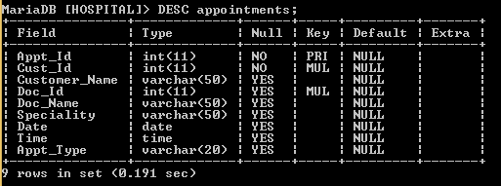

**Tables in databases**

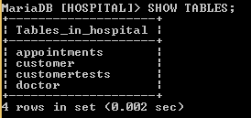

**Alter Table Command**

1. **ADD COLUMN**

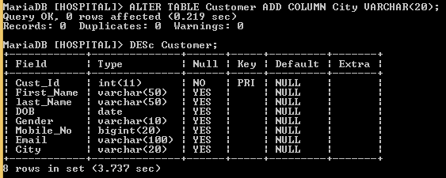

1. **MODIFY COLUMN DATA TYPE**

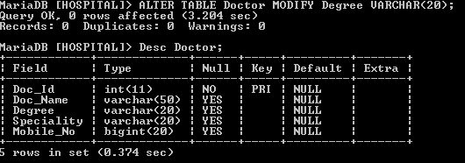

1. **RENAME COLUMN**

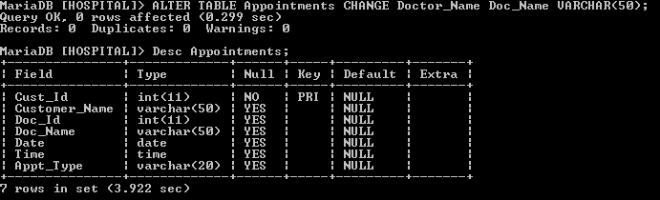

1. **DROP COLUMN**

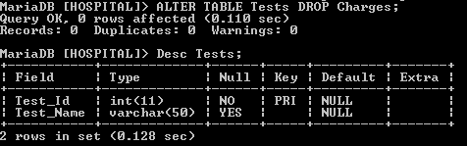

1. **RENAME TABLE**

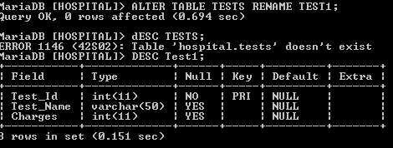

1. **TRUNCATE TABLE**



1. **DROP TABLE**



1. DATA MANIPULATION LANGUAGE (DML)

**INSERT INTO TABLE**



**UPDATE TABLE**



**DELETE FROM TABLE**



1. DATA QUERY LANGUAGE (DQL)

**SHOWING DATA FOR ALL TABLES USING SELECT QUERY**

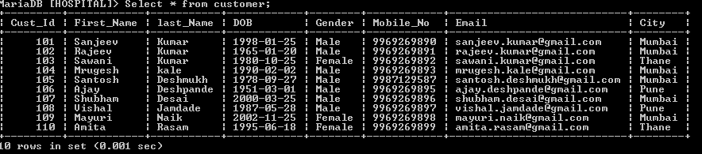

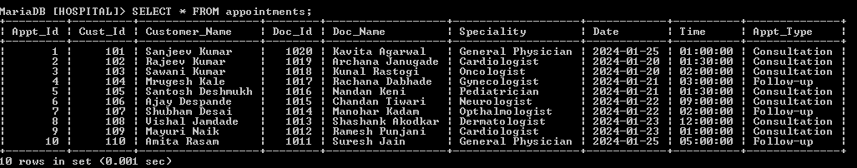

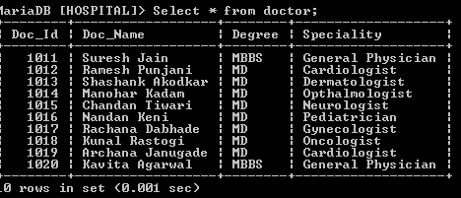

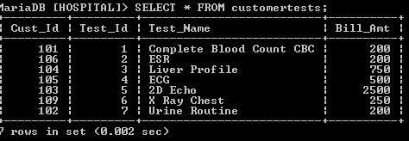

**SELECT DISTINCT**

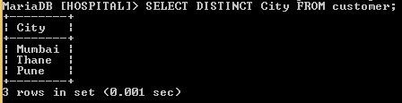

**ORDER BY CLAUSE**

1. **ASCENDING**

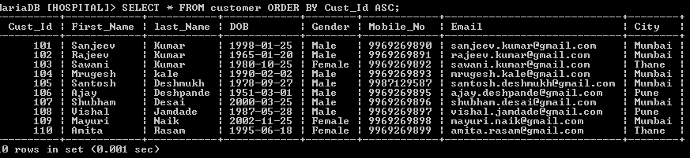

1. **DECENDING**

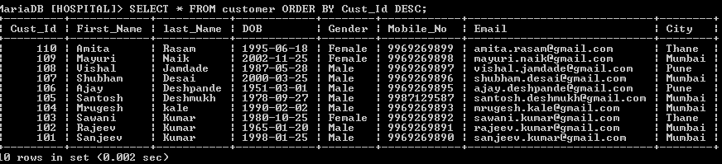

1. **ORDER BY COLUMN**

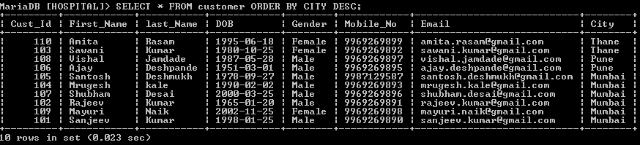

1. **LIMIT CLAUSE**

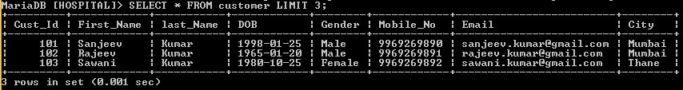

1. **SELECT QUERY WITH SPECIFIC COLUMN**

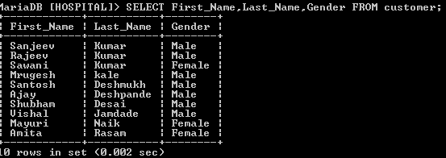

**WHERE CLAUSE**

1. **WITH COMPARISON OPERATOR**

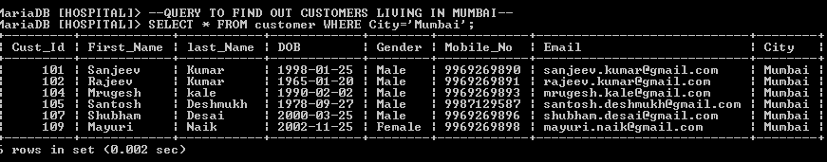

**Find all customers whose DOB is less year 2000.**

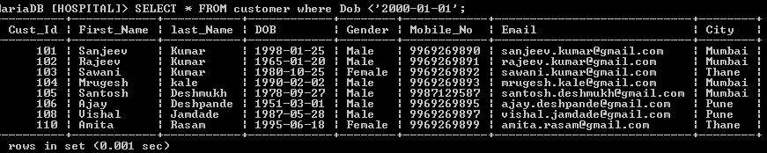

1. **WITH LOGICAL OPERATOR**

**AND OPERATOR**

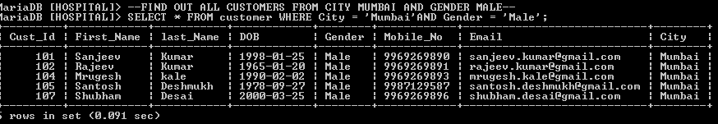

**OR OPERATOR**

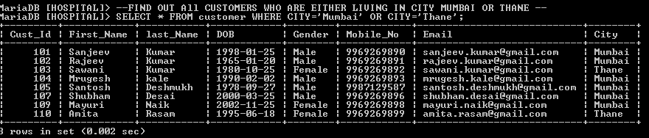

**BETWEEN OPERATOR**

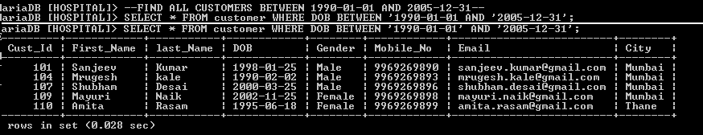

**IN OPERATOR**

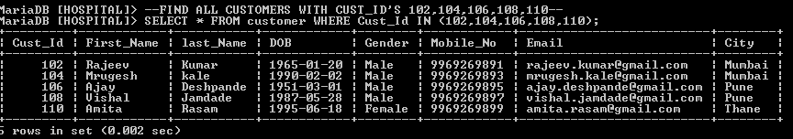

**NOT OPERATOR**

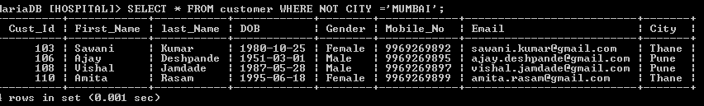

**LIKE OPERATOR**

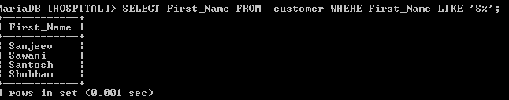

**AGGREGATE FUNCTION**

**COUNT FUNCTION**

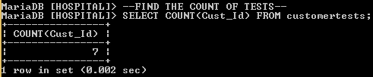

**AVERAGE FUNCTION**

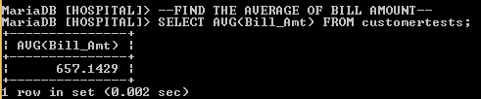

**SUM FUNCTION**

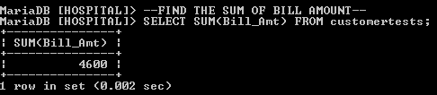

**MIN FUNCTION**

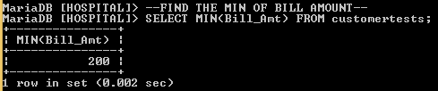

**MAX FUNCTION**

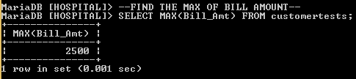

**‘GROUP BY’ CLAUSE**

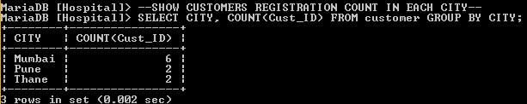

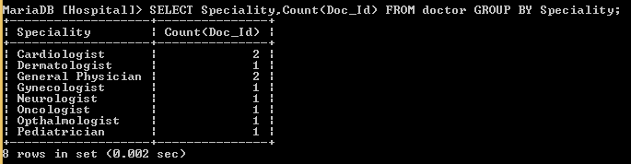

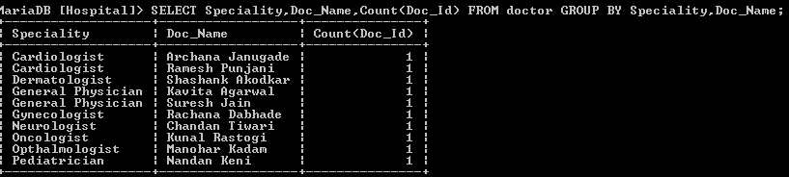

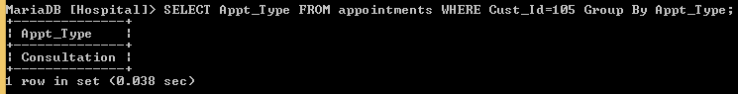

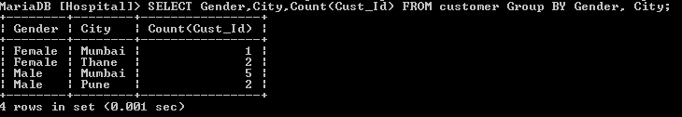

**HAVING CLAUSE**

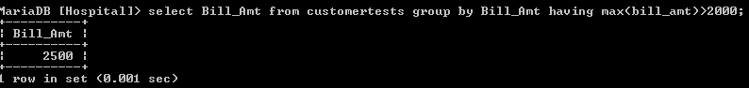

**SUB QUERY**

**Retrieve the names of customers who have appointments.**

**Inner Query – SELECT Cust_Id FROM appointments;**

**Outer Query – SELECT First_Name, Last_Name FROM customer**

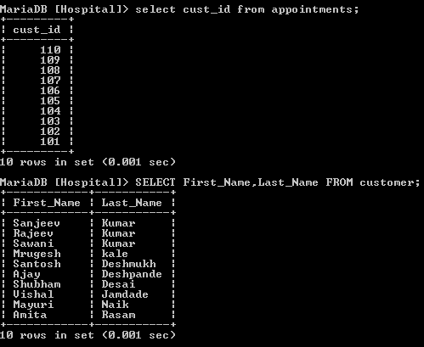

**Creating a dynamic query.**

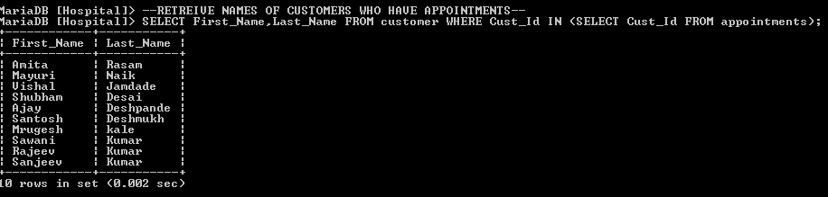

**JOINS IN SQL**

**INNER JOIN 2 TABLES i..e CUSTOMER AND APPOINTMENTS AND GET THE APPOINTMENT DATE.**

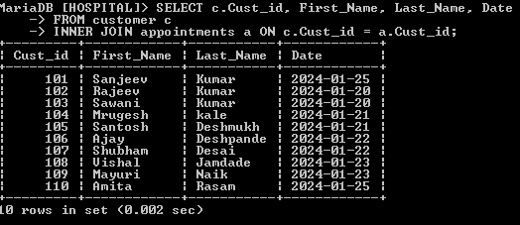

**VIEWS**

